**Validate Binary Search Tree:**

Given the root of a binary tree, *determine if it is a valid binary search tree (BST)*.

A **valid BST** is defined as follows:

* The left subtree of a node contains only nodes with keys **less than** the node's key.
* The right subtree of a node contains only nodes with keys **greater than** the node's key.
* Both the left and right subtrees must also be binary search trees.

**Example 1:**

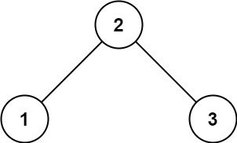

**Input:** root = [2,1,3]

**Output:** true

**Example 2:**

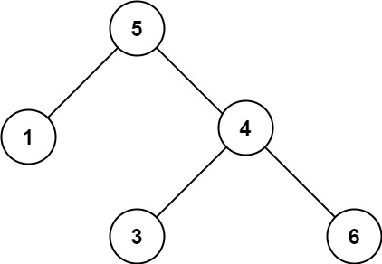

**Input:** root = [5,1,4,null,null,3,6]

**Output:** false

**Explanation:** The root node's value is 5 but its right child's value is 4.

**Constraints:**

* The number of nodes in the tree is in the range [1, 104].
* -231 <= Node.val <= 231 - 1